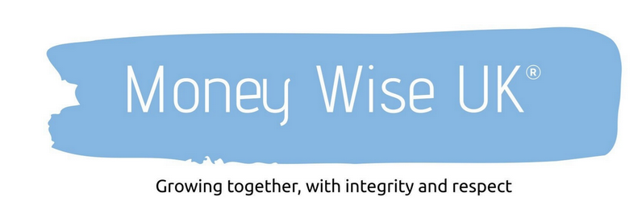

The 60-Minute Financial Health Check

You don’t need a perfect plan.
You need clarity.
This checklist is designed to help you step back once a year and review your finances calmly and objectively. No spreadsheets required. Just honesty, reflection, and an hour of your time.

Step 1: Income & Cashflow (10 minutes)

☐ I know how much money comes into my household each month
☐ My income is stable, or I understand where variability exists
☐ I know what proportion of my income I save or invest
☐ I feel comfortable with my current level of spending
☐ I know where my money tends to “leak” each month

Pause & reflect:
Do I feel in control of my cashflow, or does it feel reactive?

Step 2: Spending & Lifestyle (10 minutes)

☐ My spending broadly reflects what matters most to me
☐ I don’t regularly feel guilty or anxious about spending
☐ I know my essential vs discretionary costs
☐ I’ve allowed for enjoyment, not just responsibility
☐ I’ve avoided lifestyle creep without feeling restricted

Pause & reflect:
Where does my spending clearly support my values—and where doesn’t it?

Step 3: Emergency Planning & Resilience (10 minutes)

☐ I have an accessible emergency fund
☐ I know how many months it would cover essential expenses
☐ I feel prepared for unexpected costs
☐ I’m not relying on credit for short-term emergencies
☐ I’ve reviewed this fund within the last 12 months

Pause & reflect:
Would a financial shock cause stress—or inconvenience?

Step 4: Protection & Safety Nets (10 minutes)

☐ I know what insurance or protection I have in place
☐ My cover reflects my current life and responsibilities
☐ I understand what would happen if I couldn’t work
☐ I’ve reviewed policies in the last two years
☐ I know who would be financially affected if something happened to me

Pause & reflect:
Would my financial plan still work if life didn’t go to plan?

Step 5: Savings, Pensions & Investments (10 minutes)

☐ I know where my long-term savings are held
☐ I understand my pension arrangements
☐ My investments align with my attitude to risk
☐ I’m not reacting emotionally to market news
☐ I have a long-term strategy rather than ad-hoc decisions

Pause & reflect:
Am I investing with purpose—or reacting to noise?

Step 6: Goals, Values & Direction (10 minutes)

☐ I’m clear on what my money is ultimately for
☐ My goals reflect my values, not external pressure
☐ I’ve thought about lifestyle, not just numbers
☐ I know what “enough” might look like
☐ I’ve reviewed my goals in the last year

Pause & reflect:
Does my financial plan support the life I want—or the life I think I should want?

Final Check: Confidence & Next Steps

Tick the statement that feels closest to the truth:

☐ I feel confident and in control
☐ I feel broadly okay but could use clarity
☐ I feel uncertain and would value guidance
☐ I’m avoiding decisions I know I need to make

One Small Action

Rather than a long to-do list, write one action you’ll take in the next 30 days:

Examples:
- Organise financial documents
- Review pensions or investments
- Have a money conversation
- Book a financial review
- Do nothing—just observe spending patterns

Why This Matters

Most financial stress doesn’t come from a lack of money.
It comes from uncertainty.

An annual reset like this helps turn noise into clarity and gives you confidence to make better decisions—whether on your own or with professional support.

