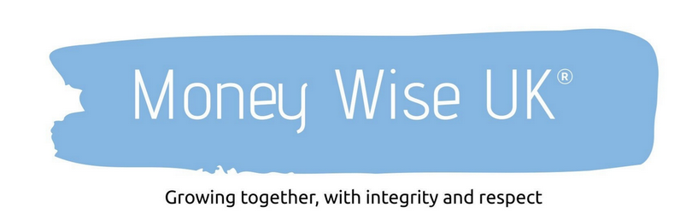

Your Relationship With Money

A Reflective Worksheet for the Start of 2026

This worksheet isn’t about judgement or perfection.
It’s about understanding what the last year has taught you, so you can make better, calmer decisions going forward.

You may want to complete this in one sitting or come back to it over a few days. There are no right or wrong answers.

Part 1: Looking Back at 2025

Take a moment to reflect on the year just gone.

1. What Went Well?

Think beyond numbers. This might include decisions, habits, or moments of clarity.

- A financial decision I feel good about:

- Something I managed better than before:

- A moment where I felt calm or confident about money:

2. What Didn’t Go So Well?

This is about learning, not self-criticism.

- Something that felt harder than expected:

- A financial habit I struggled to maintain:

- A decision I’d approach differently next time:

3. Regrets, Impulse Spending & “Rash” Decisions

If relevant, reflect honestly.

- A purchase or decision I now question:

- How was I feeling at the time? (e.g. stressed, tired, excited, pressured)

- What does this tell me about how emotions affect my money choices?

Part 2: How Money Feels Right Now

Tick the statements that feel closest to the truth today:

☐ I feel in control of my money
☐ I mostly feel organised, but could do better
☐ I feel anxious or uncertain about money
☐ I avoid thinking about money
☐ I feel confident making financial decisions
☐ I rely heavily on guesswork or instinct

Now reflect:

- If I had to describe my current relationship with money in one sentence, it would be:

Part 3: Values – What Really Matters?

Money is a tool. It works best when it supports what matters most.

1. What Do I Value Most Right Now?

Choose up to five words or themes:

☐ Security
☐ Freedom
☐ Family
☐ Experiences
☐ Simplicity
☐ Generosity
☐ Comfort
☐ Growth
☐ Flexibility
☐ Peace of mind
☐ Other: _______________________

2. Alignment Check

- Where did my money clearly support my values in 2025?

- Where did it drift away from them?

Part 4: Goals – Turning Meaning Into Direction

Before thinking about how much money you need, reflect on why.

1. Looking Ahead to 2026

- One thing I want more of this year:

- One thing I want less of:

2. A Meaningful Financial Goal

This doesn’t need to be technical.

- A financial goal that genuinely matters to me:

- Why this matters to my life (not just my bank balance):

Part 5: One Small Step

Change doesn’t come from grand resolutions. It comes from small, intentional steps.

- One simple action I can take in the next 30 days:

Examples might include:

- Having a money conversation
- Reviewing spending without changing anything yet
- Organising paperwork
- Booking a review or advice meeting
- Simply paying attention to how money decisions feel

Final Reflection

Complete this sentence:

“If I were more intentional with money in 2026, my life might feel…”

How This Worksheet Is Intended to Be Used

- Individually — as a quiet reflection
- With a partner — to align values and goals
- With an adviser — as a starting point for meaningful planning

It’s not about fixing everything.
It’s about understanding yourself better, and letting money support the life you actually want.

